Additional 01 - Finite State Machine Programming Assignment # 2

By

408262416

陳嬿婷

X86 Assembly Language Fall 2020

Date Submitted: November 30, 2020

# Analysis: (if asked)

Answer the questions if asked in the descriptions of the assignment.

# Test Plan and Test Cases (required):

Briefly describe how you plan to test each function (if there is any) and the overall programs. For each function (if applicable) and the program you prepare some test cases. The test cases may be presented in a table form. For example,

|  |  |  |
| --- | --- | --- |
| **Test Case Number** | **Input Values** | **Expected output** |
| 1 | 408262999 | Odd count: 3  Even sum: 22 Result: 3*22 = 66 |
| 2 | 408250317 | Odd count: 4  Even sum: 14 Result: 4*14 = 64 |
| 3 | -1abc | Error (Undefined) |
| … |  |  |

# Feedback: (required)

Informally tell us what could be improved.

Was it too difficult, or too easy?

不會很難，只是在畫FSM的時候花了一點時間思考

Was the assignment fun or challenging?

For challenging

Was there something that was unclear?

沒有Test case可以測試因為繳交範本跟小組作業為同一份

Was the project too long for the given amount of time?.

不會

# Appendix A: Test Log (required)

This section should contain the **results of your testing phase**. It is not necessary that you type this section (turning in the actual log is fine, and preferred). The test log should contain the test case number, the date and time that the test was performed, the actual outputs, and the test result (either pass or fail). It is expected that not all test cases will necessarily pass on the first attempt. For any test case where the initial result is fail, there should eventually be another test that shows the passing of that test case. The test cases can be presented in table format. For example

|  |  |  |  |  |
| --- | --- | --- | --- | --- |
| **Test Case Number** | **Input Values** | **Date &Time** | **Actual Output** | **Result** |
| 1 | 001-1 | 11/29/20 03:15 AM | The input contains even number of 0s. | Pass |
| 2 | 0011-1 | 11/29/20 03:16 AM | The input contains even number of 0s. | Pass |
| 3 | 0001-1 | 11/29/20 03:17 AM | The input contains odd number of 0s. | Pass |
| 4 | 11001-1 | 11/29/20 03:18 AM | The input contains even number of 0s. | Pass |

# Appendix B: Source Code (required)

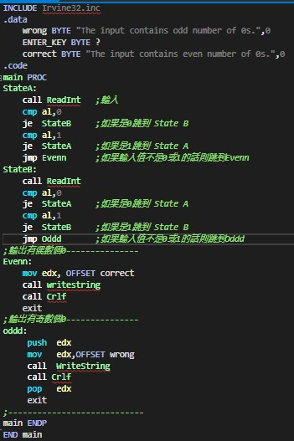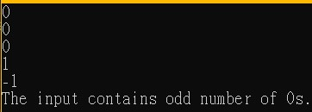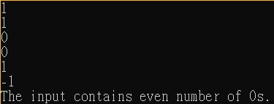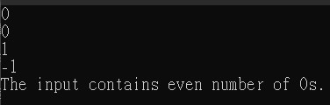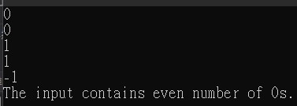This section should contain a printed copy of your program, complete with all necessary documentation. ***Be sure your comments accurately describe what is going on in the code.***